International Civil Aviation Organization
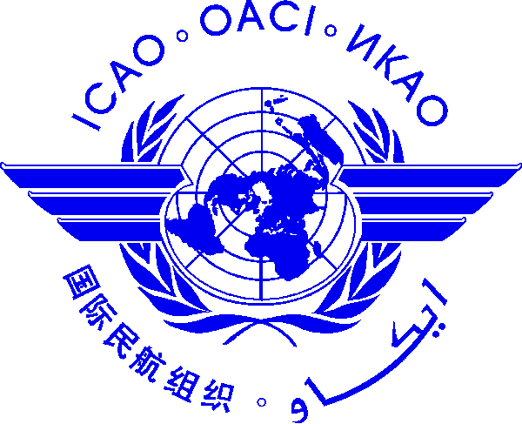 |  | Dangerous Goods Technical Course  Please indicate as appropriate:   Initial Training on Dangerous Goods Technical Instructions  21-25 January 2013 Bangkok, Thailand   Specialized Training – Infectious Substances  28 January 2013 Bangkok, Thailand   Specialized Training – Radioactive Materials  29 January 2013 Bangkok, Thailand   Recurrent Training on Dangerous Goods Technical Instructions  30 January to 1 February 2013 Bangkok, Thailand

Nomination Form [please type or print]

State/ Organization
Name | Title |  |  | Family name (capitals) |  |  | First name |  |  | Middle initial
 | Mr/Ms/Dr
Status |  |  | Principle Delegate |  |  | Delegate |  |  | Advisor
Official Position
Mailing Address
Telephone (office)
Fax
(office)
E-mail
Hotel in Bangkok

Note 1: Participants are expected to make their own hotel/visa arrangements.
Note 2: All material will be provided in booklet mean and electronic copy to participants.

Date ..........................……….... Signature ………….....………...

After completing, please send to: ICAO Asia and Pacific Office 252/1 Vibhavadee-Rungsit Road, Chatuchak, Bangkok 10900 Thailand. Fax: 66 (2) 537 8199 or E-mail: apac@icao.int with copy to
Khun Nong, COSCAP-SEA Administrative Assistant E-mail: khun.nong@coscap-icao.org by 11 January 2013

